[Basic SELECT Statement](https://lagunita.stanford.edu/courses/DB/SQL/SelfPaced/course/" \l "i4x://DB/SQL/sequential/seq-vid-basic_select_statement) ：



* Underline: key relation

Apply: (sID, cName, major)-> key

1. Select all student with **bio related** major:

Select sID, major

From Apply

Where major **like** ‘%bio%’;

1. **Cross-product** of two table (e.g Student, College)

Select *

From Student, College

*We'll just do the cross-product and student college **without any combination,** and we'll **do select star to get all the attributes out.**

[Table Variables and Set Operators](https://lagunita.stanford.edu/courses/DB/SQL/SelfPaced/course/#i4x://DB/SQL/sequential/seq-vid-table_variables_and_set_operators) ：

Set Operators: Union, Intersect, Except

/**************************************************************

Pairs of students with same GPA

**************************************************************/

select S1.sID, S1.sName, S1.GPA, S2.sID, S2.sName, S2.GPA

from Student S1, Student S2

where S1.GPA = S2.GPA;

/*** **Get rid of self-pairings** ***/

/*** this may have pair with repeat in reverse order such as (yang,zhang) and (zhang,yang) ***/

select S1.sID, S1.sName, S1.GPA, S2.sID, S2.sName, S2.GPA

from Student S1, Student S2

where S1.GPA = S2.GPA and S1.sID **<>** S2.sID;

/*** **Get rid of reverse-pairings** ***/

select S1.sID, S1.sName, S1.GPA, S2.sID, S2.sName, S2.GPA

from Student S1, Student S2

where S1.GPA = S2.GPA and S1.sID **<** S2.sID;

1. Union operator:

-Union- remove duplicate (ordered)

select cName as name from College

union

select sName (as name) from Student;

-Union all-all item

select cName as name from College

union all

select sName (as name) from Student

**order by name;** #need order by

1. intersect operator:

# **we find that there are indeed two students who applied to CS and EE**

select sID as ID from Apply where major=’EE’

intersect

select sID as ID from Apply where major=’CS’;

Some system does not support “intersect”:

=>

Select **distinct** A1.sID

From Apply A1, Apply A2

Where A1.sID=A2.sID and A1.major=’CS’ and A2.major=’EE’;

1. except/minus operator:

# **who applied to CS but did not apply to EE.**

Select sID as ID from Apply where major=’CS’

Except

Select sID as ID from Apply where major ‘EE’

For some system does not support ‘Except’:

# the query does not work well because the “A2.major <> 'EE'” could also be ‘CS’ major.

select distinct A1. sID

from Apply A1, Apply A2

where A1.sID = A2.sID and A1.major = 'CS' and A2.major <> 'EE';

Where Subquery (from section [Subqueries in WHERE Clause](https://lagunita.stanford.edu/courses/DB/SQL/SelfPaced/course/#i4x://DB/SQL/sequential/seq-vid-subqueries_in_where) )

1.in& not in

**#Works!!!!!**

Select sID

From Student

Where sID in (select sID from Apply where major=’CS’)

And sID not in (select sID from Apply where major=’EE’);

Same way

Select sID

From Student

Where sID in (select sID from Apply where major=’CS’)

And not sID in (select sID from Apply where major=’EE’);



2.any

**#Works!!!!!**

Select sID, sName

From Student

Where sID = any ( select sID from Apply where major=’CS’)

and not sID = any ( select sID from Apply where major=’ EE’);

select sID, sName

from Student

where sID = any (select sID from Apply where major = 'CS')

and sID <> any (select sID from Apply where major = 'EE');

# not works!!!

Because it check anybody applied to EE not equal to sID we looking at (not constrain into ‘CS” major)

[Subqueries in WHERE Clause](https://lagunita.stanford.edu/courses/DB/SQL/SelfPaced/course/#i4x://DB/SQL/sequential/seq-vid-subqueries_in_where) :

#select student ID and student name who have applied cs major at some college.

select sID, sName

from Student

where sID in (select sID from Apply where major = 'CS');

# same as

Select **distinct** Student.sID,sName

From Student, Apply

Where Student.sID=Apply.sID and major=’CS’

#Because some students may apply CS major at several different college, there are some duplicates in the above query. We need use **distinct** to remove duplicates.

#only student name who have applied cs major at some college.

Select sName

From Student

Where sID in (select sID from Apply where major=’CS’);

# duplicate name because of different ID.

Select distinct sName

From Student, Apply

where Student.sID = Apply.sID and major = 'CS';

# no duplicate name because of “distinct sNmae” query.



#duplicate are important: Avg_GPA

Select GPA

From Student

Where sID in (select sID from Apply where major=’CS’);

#Join version with and without distinct

Select GPA

From Student, Apply

where Student.sID = Apply.sID and major = 'CS';

#If we use this result to compute the average GPA, we'll be counting some students multiple times. And presumably, that's not what we want to do.

Select distinct GPA

From Student, Apply

where Student.sID = Apply.sID and major = 'CS';

# Because we distinct GPA, we may not get correct number of students. GPA we need. For example, if we have two students have same GPA 3.8 and 3.8. One of 3.8 will be remove.

So, in this case, neither the version with distinct nor the version without distinct gives us the right number of GPAs. Neither of those will give us the correct average.

**Exists:**

The EXISTS condition in SQL is used to check whether the result of a correlated nested query is empty (contains no tuples) or not.

#all college such that some other college is in the same state

Select C1.cName, C1.state

From College C1

Where exists (Select * from College C2

Where C1. state=C2.state and **C1. cName<>C2.cName**);

# a college must stay in the same state as itself.

#a **max** can be written using sub-queries: **(a kind of query we can find the largest and smallest)**

**# The highest enrollment**

Select C1.cName

From College C1

Where not exists (Select * from College C2

Where C2. enrollment>C1.enrollment);

**#the highest GPA**

# all students have highest GPA

Select S1. sName

From Student S1

Where not exists (Select * from Student S2

Where S2. GPA>S1. GPA);

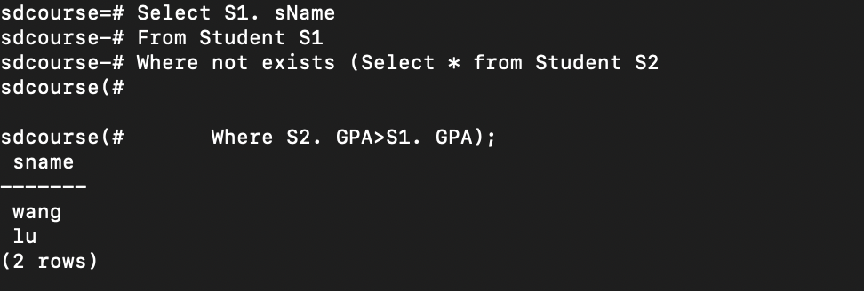

# find all student except the student with lowest GPA

Select distinct S1. sName, S1. GPA

From Student S1, Student S2

Where S1.GPA>S2.GPA

**All**:

all for checking whether a value has relationship with all of the results of a sub query.

# students who have highest GPA

Select S1. sName, S1. GPA

From Student S1

Where S1.GPA >= all (select GPA from Student);

If the student's GPA is indeed **greater than or equal to all GPA's** then **the student has the highest GPA** in the database.

# if all the value is **unique**, we can find the highest by using:

Select S1. sName, S1. GPA

From Student S1

Where S1.GPA > all (Select GPA from Student S2

Where S1. sID<>S2.sID);

Select C1. cName, C1. enrollment

From College C1

Where C1. enrollment > all (Select C2. enrollment from College C2

Where C1. cName<> C2. cName);



**Any:**

any says you must satisfy the condition with at least one element of the set.

# highest enrollment

Select C1. cName, C1. enrollment

From College C1

Where **not** C1. enrollment **<=any** (Select C2. enrollment from College C2

Where C1. cName<> C2. cName);

#students not from the smallest size high school

Select S1. sName, S1.sizeHS

From Student S1

Where S1. sizeHS> any (Select sizeHS from Student);



#Some systems don't support Any/All

Select S1.sName, S1.sizeHS

From Student S1

Where exists (Select * from Student S2

Where S2.sizeHS< S1.sizeHS)

[Subqueries in FROM and SELECT](https://lagunita.stanford.edu/courses/DB/SQL/SelfPaced/course/#i4x://DB/SQL/sequential/seq-vid-subqueries_in_from_and_select) ：

#Colleges paired with the highest GPA of their applicants

Select distinct C.cName, C.state, S1.GPA

From College C, Student S1, Apply A1

Where C. cName=A1. cName and S1.sID=A1.sID

and S1.GPA >=all ( Select S2.GPA from Student S2, Apply A2

Where C. cName=A2. cName and S2. sID=A2.sID);

/*** Use subquery in Select ***/

select distinct dcName, state,

(select distinct GPA

from Apply, Student

where College.cName = Apply.cName

and Apply.sID = Student.sID

and GPA >= all

(select GPA from Student, Apply

where Student.sID = Apply.sID

and Apply.cName = College.cName)) as GPA

from College;



[The JOIN Family of Operators](https://lagunita.stanford.edu/courses/DB/SQL/SelfPaced/course/#i4x://DB/SQL/sequential/seq-vid-join_operators) ：

1. inner join
2. natural join
3. inner join using (attrs): that's kind of again like the natural join, except you explicitly list the attributes that you want to be equated
4. left outer join, right outer join and full outer join

* join is an abbreviation for inner join

Select distinct sName, major

From Student (inner) join Apply

On Student.sID=Apply.sID;

Three table join:

/*** Works in SQLite and MySQL but not Postgres ***/

select Apply.sID, sName, GPA, Apply.cName, enrollment

from Apply join Student join College

on Apply.sID = Student.sID and Apply.cName = College.cName;

/*** Rewrite using **binary JOIN** ***/

select Apply. sID, sName, GPA, Apply. cName, enrollment

from **(Apply join Student on Apply. sID = Student. sID)** join College

on Apply. cName = College. cName;

* natural join:

e.g

1.

Select distinct sName, major

Student natural join Apply;

2.

Select sName, GPA

From Student natural join Apply

Where sizeHS<1000 and major=’CS’ and cName=’Stanford’;

/**considered safer**/

Select sName, GPA

From Student natural join Apply **using (sID)**

Where sizeHS<1000 and major=’CS’ and cName=’Stanford’;

3.self-join pairs

Select S1.sID, S1.sName, S1.GPA, S2.sID, S2.sName, S2.GPA

From Student S1 join Student S2 using (GPA)

where S1.sID < S2.sID;

wrong: on S1.sID < S2.sID;

* most SQL systems do not allow you to have both a using clause and an on clause in combination with the join.
* Outer join

1. Left/right join using (attrs), natural left outer join

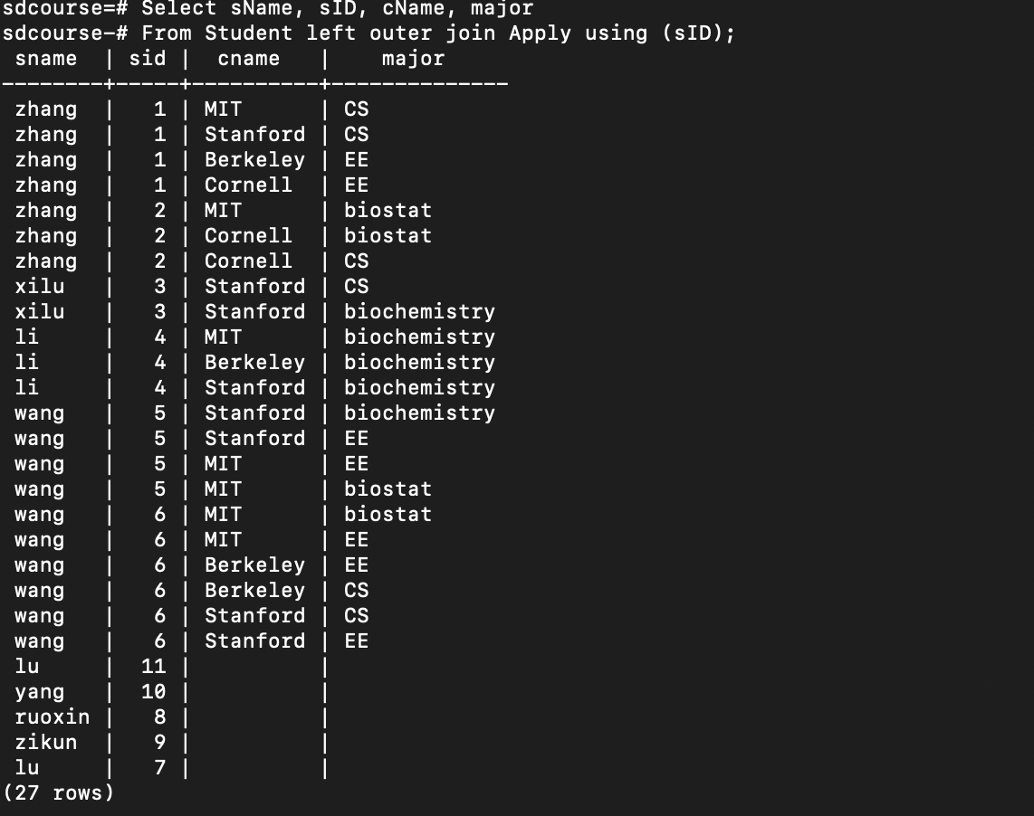#there are some students have not applied college

Select sName, sID, cName, major

From Student left (outer) join Apply using (sID);

/**same as**/

Select sName, sID,cName, major

From Student natural left outer join Apply;

/** without using join operator**/

Select sName, sID, cName, major

From Student, Apply

Where Student. sID=Apply. sID ##inner join part select all the student have applied Union colleges.

Select sName, sIDID, Null, Null

From Student

Where Student.sID not in (select sID from Apply);

##students who have not applied colleges with cName and major is null.

1. Full outer join… using(attrs)

Select sName, sID, cName, major

From Student full outer join Apply using (sID);

/**same as**/

Select sName, sID, cName, major

From Student left join Apply using (sID)

Union

Select sName, sID, cName, major

From Student right join Apply using (sID)

/*** Note UNION eliminates duplicates ***/

**Communicatively and Associativity:**

Communicatively: (A op B) = (B op A)

Associativity: A op (B op C) = (A op B) op C

###none of outer join are associativity

### full outer join is communicative, but others are not.



[Aggregation](https://lagunita.stanford.edu/courses/DB/SQL/SelfPaced/course/#i4x://DB/SQL/sequential/seq-vid-aggregation)：

* Min, max, sum, avg, count
* Two new clauses:

**group by** columns

**having** condition

#count number of students apply Cornell

Select count(*)

From Apply

Where cName=’Cornell’;

# The student will be counting **several times** if he/she apply the Cornell several different majors.

#distinct

Select (**distinct sID**)

From Apply

Where cName=’Cornell’;

In the count function, we can put a special keyword distinct and then the name of **one or more attributes**

and in this case what the count will do, is will look at the resultand then it will **count the distinct values for the particular attribute.**



/**************************************************************

Number of colleges applied to by each student, including

0 for those who applied nowhere

**************************************************************/



(select Student.sID, count(distinct cName)

from Student, Apply

where Student.sID = Apply.sID

group by Student.sID)

union

(select sID, 0

from Student

where sID not in (select sID from Apply)

)

order by sID;

Having: What the having clause allows us to do is **apply conditions to the results of aggregate functions.** So, the having clause is applied **after the group by clause** and it allows us to check conditions that involve the entire group. In contrast the **where clause applies to one tuple at a time**.

#Select colleges which have less than 5 application

Select cName

From Apply

Group by cName

Having Count(*)<5

##Without Using Having query

Select distinct cName

From Apply A1

Where 5>( select count(*) from Apply A2 where A1.cName=A2.cName);

#select colleges which have less than 5 applicants

Select cName

From Apply

Group by cName

Having Count(distinct sID)<5;

# select major whose highest application GPA is lower than avg GPA of all student

Select major

From Apply a, Student s

Where a.sID=s.sID

Group by major

Having max(gpa)<( select avg(gpa) from student)

[NULL Values](https://lagunita.stanford.edu/courses/DB/SQL/SelfPaced/course/#i4x://DB/SQL/sequential/seq-vid-null_values):

The way the where clause is evaluated when null values are involved is using a three valued logic where every expression is either true or false or unknown.

# count distinct GPA in student

Select count (distinct GPA)

From Student

Where GPA is not null;

/** is same as**/

Select count (distinct GPA)

From Student;

### we are not counting null value

/**However**/

Select distinct GPA

From Student;

## contain null value

[Data Modification Statements](https://lagunita.stanford.edu/courses/DB/SQL/SelfPaced/course/#i4x://DB/SQL/sequential/seq-vid-data_modification_statements) :

* Inserting data



* Deleting date
* It says we delete from table where a certain condition is true.
* **Every tuple** in the table that satisfies this condition will be deleted.
* Updating existing data



* The condition can have sub-queries and so on.
* Expression can be queries over other tables or the same table in the database.



* update simultaneously any number of attributes.

# insert data with self-statement:

Insert into Apply

Select sID, 'Carnegie Mellon','CS',null

From student

Where sID not in (Select sID from apply);

# delete from … where…:

/**************************************************************

Delete all students who applied to more than two different

majors

**************************************************************/

Step1: who will be deleted /**find student who applied more than 2 majors**/

Select sID, count (distinct major)

From apply

Group by sID

Having count (distinct major)>2;

Step2: delete from... Where…

Delete from Student

Where sID in

(Select sID

From apply

Group by sID

Having count (distinct major)>2);

/** delete both from Student table and Apply table**/

/*** **NOTE** SOME SYSTEMS DISALLOW THE OPERATION BECAUSE OF DELETE FROM TABLE IS SAME AS THE WHERE CONDITION TABLE***/

Delete from Apply

Where sID in

(Select sID

From apply

Group by sID

Having count (distinct major)>2);

#update

/**************************************************************

Accept applicants to Carnegie Mellon with GPA < 3.6 but turn

them into economics majors

**************************************************************/

Step 1: figure out who will be update

Select *

From Apply

Where cName=’ Carnegie Mellon’

And sID in ( Select sID from Student where GPA<3.6);

Step 2: update... set… where…

Update Apply

Set major=’Economics’, decision=’Y’

Where ( cName=’ Carnegie Mellon’

And sID in ( Select sID from Student where GPA<3.6) );

/**************************************************************

Turn the highest-GPA EE applicant into a CSE applicant

**************************************************************/

Step 1: figure out who will be update

Select *

From Apply

Where major=’EE’

And sID in (Select sID From Student S1

Where S1.GPA >= all (Select GPA From Student

Where GAP is not Null

And sID in

(Select sID From Apply

Where major=’EE’)

)

);

Step 2 update:

**Update Apply**

**Set major=’CSE’**

Where major=’EE’

And sID in (Select sID From Student S1

Where S1.GPA >= all (Select GPA From Student

Where GAP is not Null

And sID in

(Select sID From Apply

Where major=’EE’)

)

);